Cardiac Patient Monitoring System

API Testing Documentation

1. Testing Overview
The API was tested through the project's Swagger/OpenAPI interface.
Swagger provides an interactive interface for sending HTTP requests to the API and checking the returned responses.
Testing focused on:
- Authentication
- Authorization
- CRUD operations
- Validation
- Patient-specific queries
- Error handling
- HTTP status codes
- Role-based access

2. Swagger Interface
The Swagger UI displays the available API controllers and endpoints.
The main controllers available for testing are:
- Auth
- Patients
- VitalSigns
- Medications
- Appointments

Screenshot
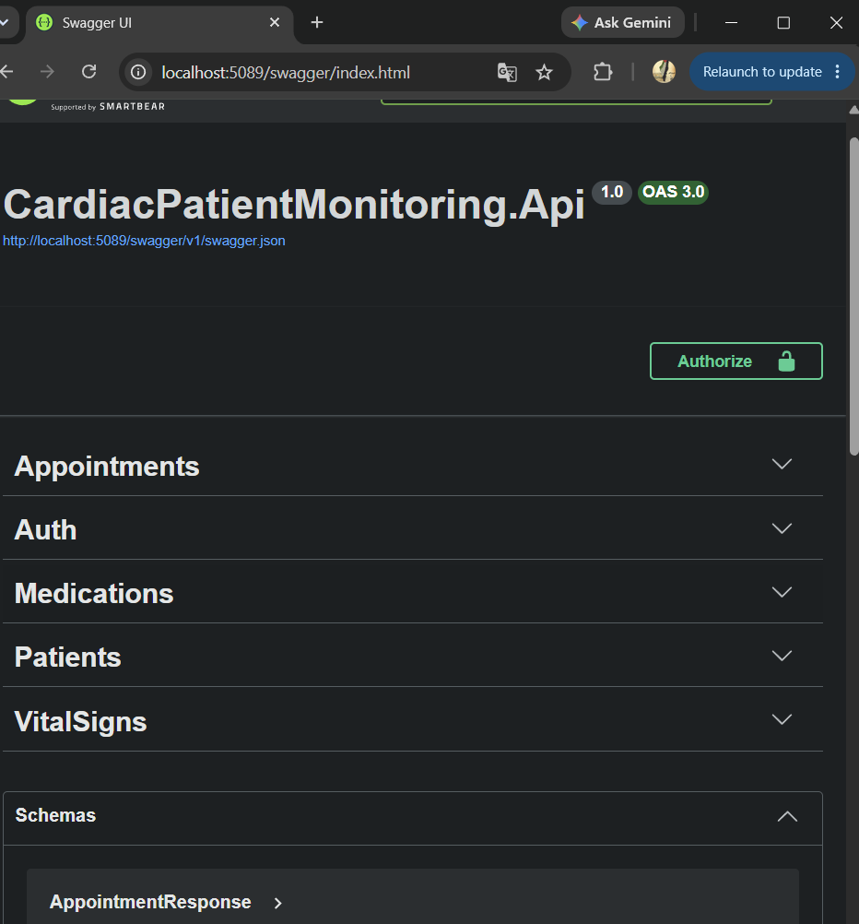

3. Authentication Testing
Authentication was tested through the Auth endpoints.
The two main authentication operations are:
POST /api/Auth/register
POST /api/Auth/login

4. User Registration Test

Endpoint
POST /api/Auth/register

Purpose
Creates a new application user.

Request
The request contains:
{
"email": "user@example.com",
"password": "Password123!"
}

Expected Result
A successful registration returns:
200 OK
with a success message.

Screenshot
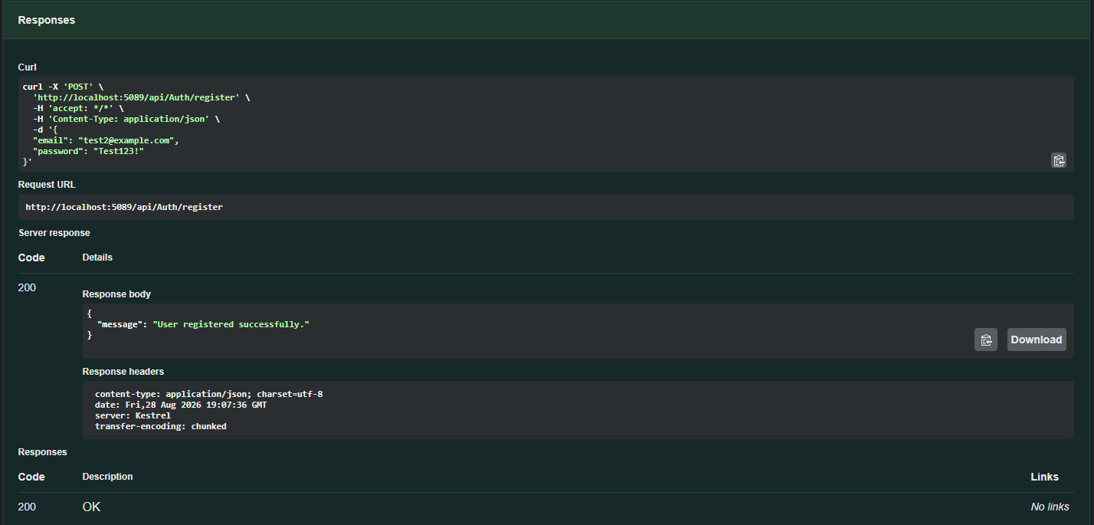

5. Duplicate Registration Test
The registration endpoint checks whether the email is already registered.
If the email already exists, the API returns:
409 Conflict
with:
Email is already registered.

Screenshot
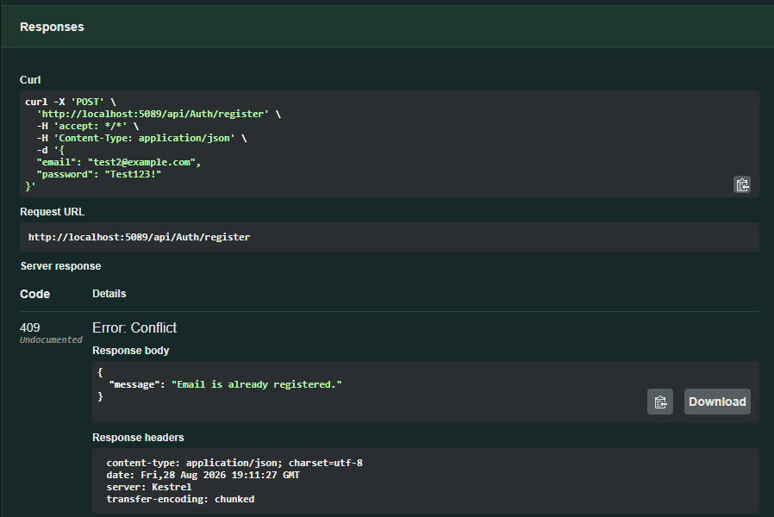

6. Login Test

Endpoint
POST /api/Auth/login

Purpose
Authenticates an existing user and returns a JWT token.

Expected Result
A successful login returns:
200 OK
The response contains:
- JWT token
- Token expiration time

Screenshot
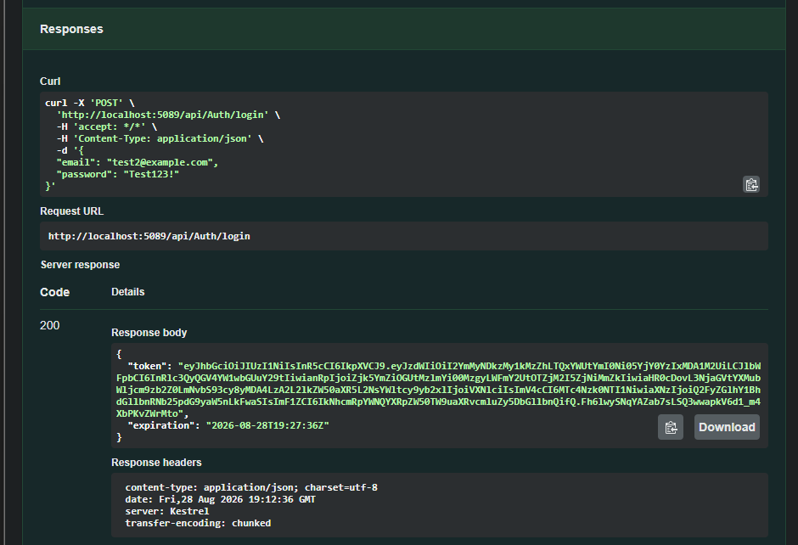

7. JWT Authorization Testing
After successful login, the returned JWT token is used to access protected endpoints.
Swagger provides the Authorize button for Bearer authentication.
The token is entered using the Bearer authentication scheme.

Screenshot
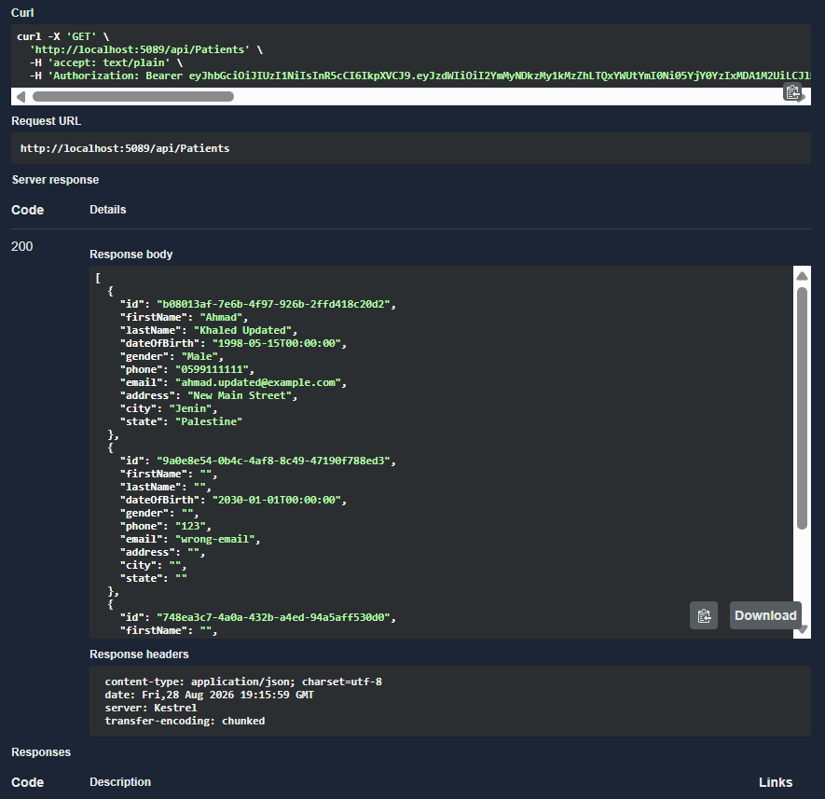

8. Unauthorized Request Test
Protected controllers use:
[Authorize]
Therefore, attempting to access a protected endpoint without a valid JWT should result in:
401 Unauthorized

Example
GET /api/VitalSigns
without authentication.

Expected Result
401 Unauthorized

Screenshot
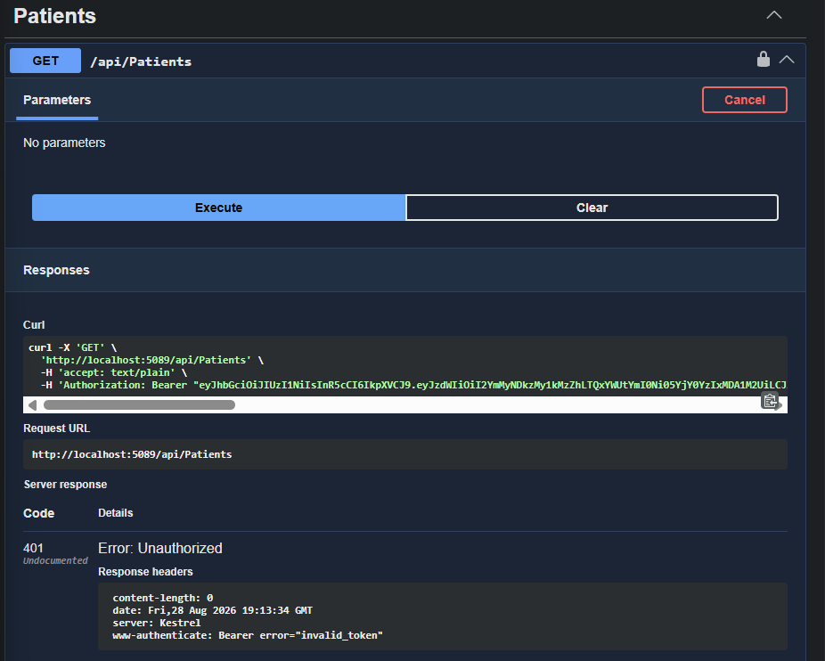

9. Patient API Testing
The Patients controller is tested for patient management operations.
Testing includes:
- Retrieve patients
- Retrieve a patient
- Create patient
- Update patient
- Delete patient

10. Get All Patients

Endpoint
GET /api/Patients

Purpose
Retrieves the available patient records.

Expected Result
200 OK
The response contains patient information through PatientResponse.

Screenshot
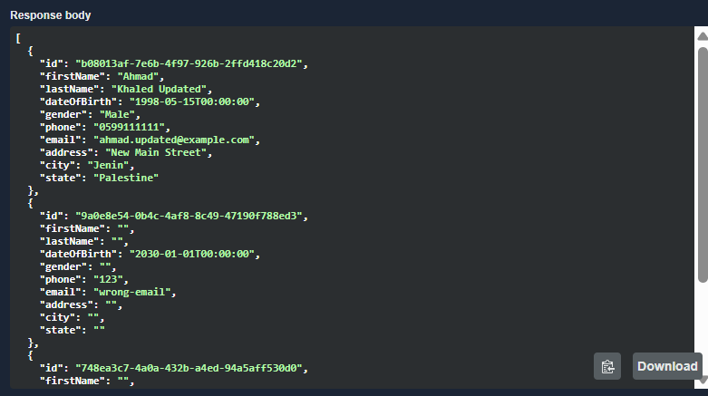

11. Get Patient by ID

Endpoint
GET /api/Patients/{id}

Purpose
Retrieves a specific patient using the patient's GUID.

Expected Result
Existing patient:
200 OK
Non-existing patient:
404 Not Found

Screenshots
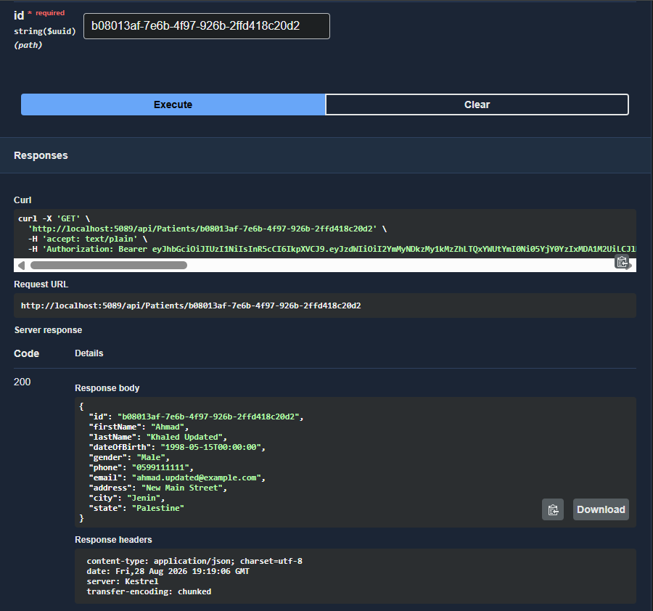 [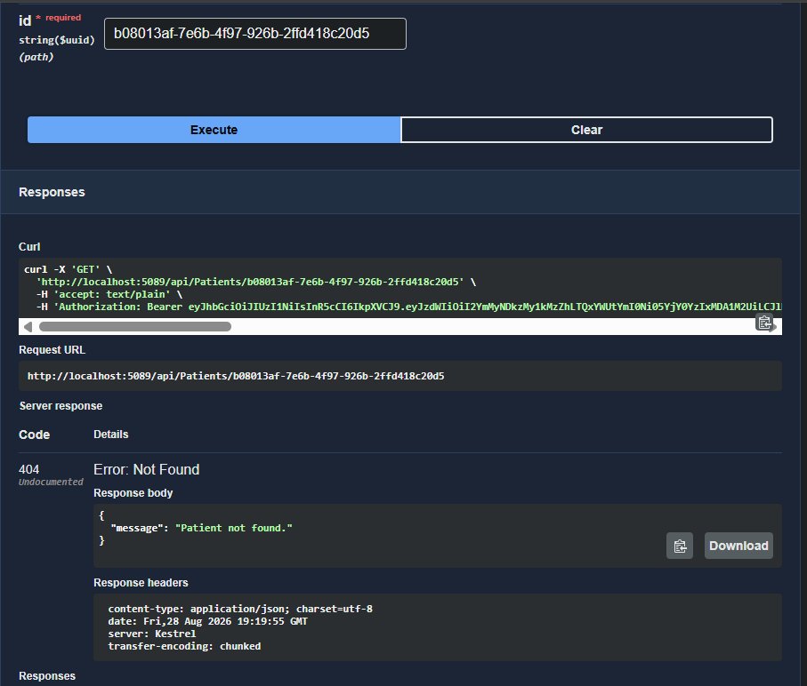

12. Create Patient

Endpoint
POST /api/Patients

Purpose
Creates a new patient.
The request uses:
CreatePatientRequest
The request is validated using FluentValidation before the patient is created.

Expected Results
Valid request:
201 Created
Invalid request:
400 Bad Request

Screenshots
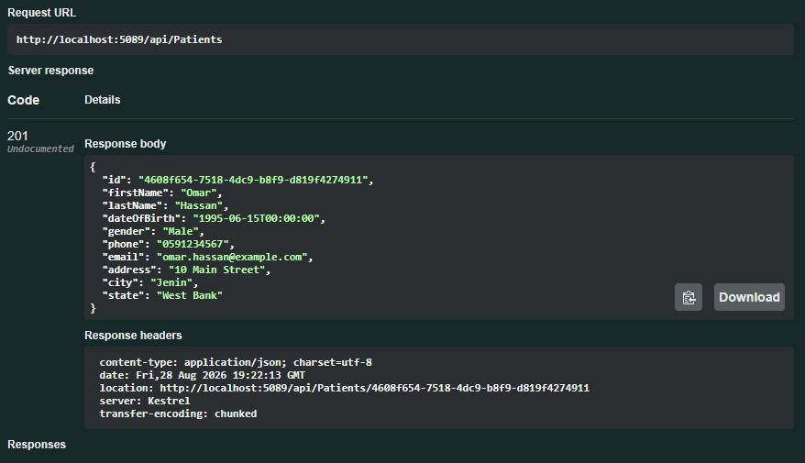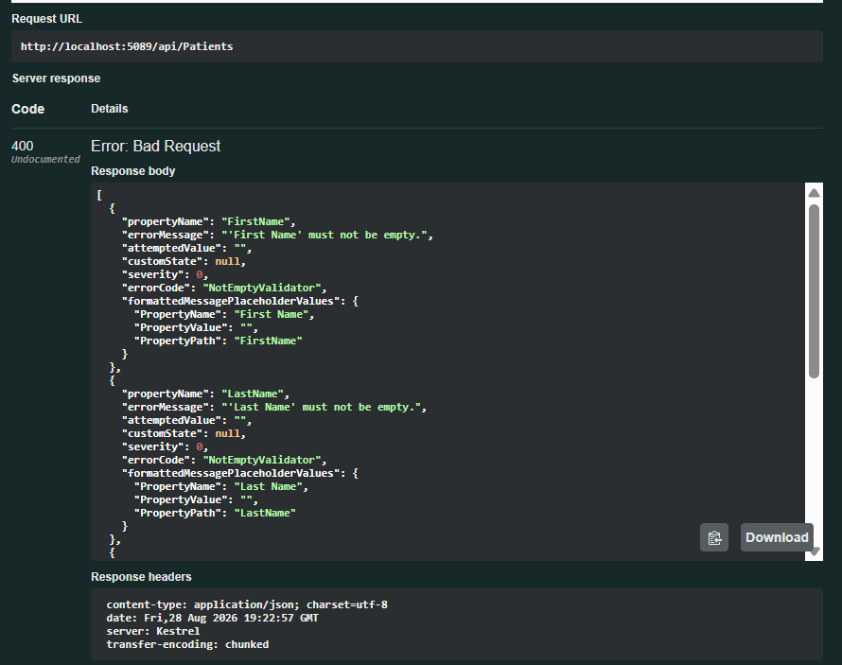

13. Update Patient

Endpoint
PUT /api/Patients/{id}

Purpose
Updates an existing patient.
The request uses:
UpdatePatientRequest
The request is validated before the update.

Expected Results
Successful update:
204 No Content
Patient not found:
404 Not Found
Validation failure:
400 Bad Request

Screenshots
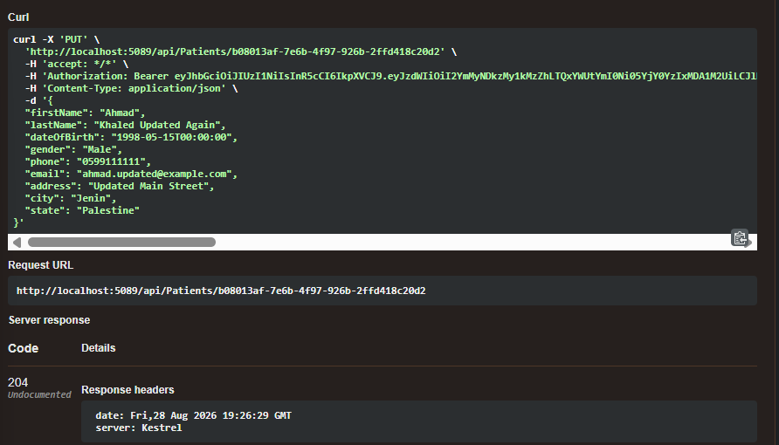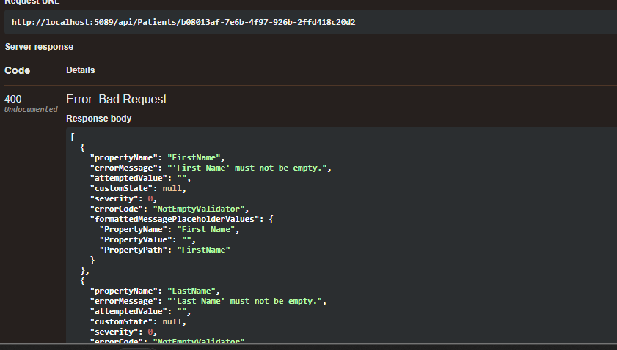

14. Delete Patient

Endpoint
DELETE /api/Patients/{id}

Purpose
Deletes a patient.
The endpoint requires the Admin role.

Expected Results
Admin user:
204 No Content
Authenticated non-admin user:
403 Forbidden
Non-existing patient:
404 Not Found

Screenshots
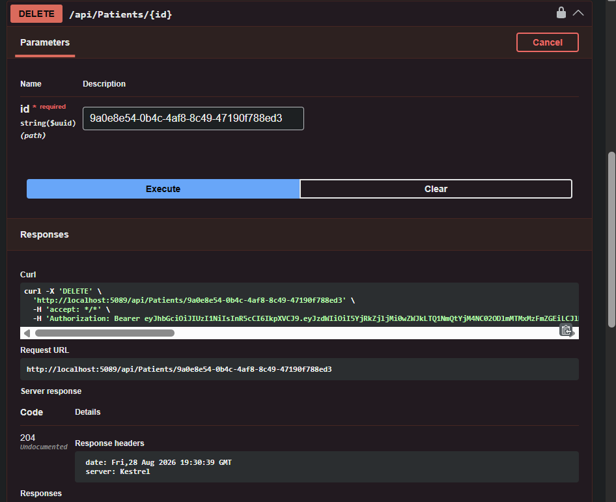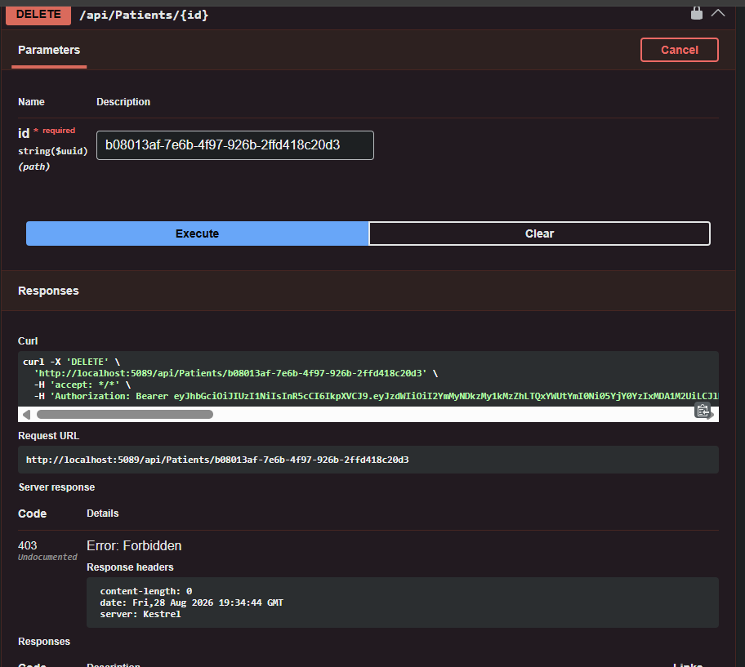

15. Vital Signs API Testing
The Vital Signs controller provides:
- Get all vital signs
- Get vital sign by ID
- Get patient vital signs
- Create vital sign
- Update vital sign
- Delete vital sign

16. Get All Vital Signs

Endpoint
GET /api/VitalSigns

Expected Result
200 OK
The response contains vital-sign measurements.

Screenshot
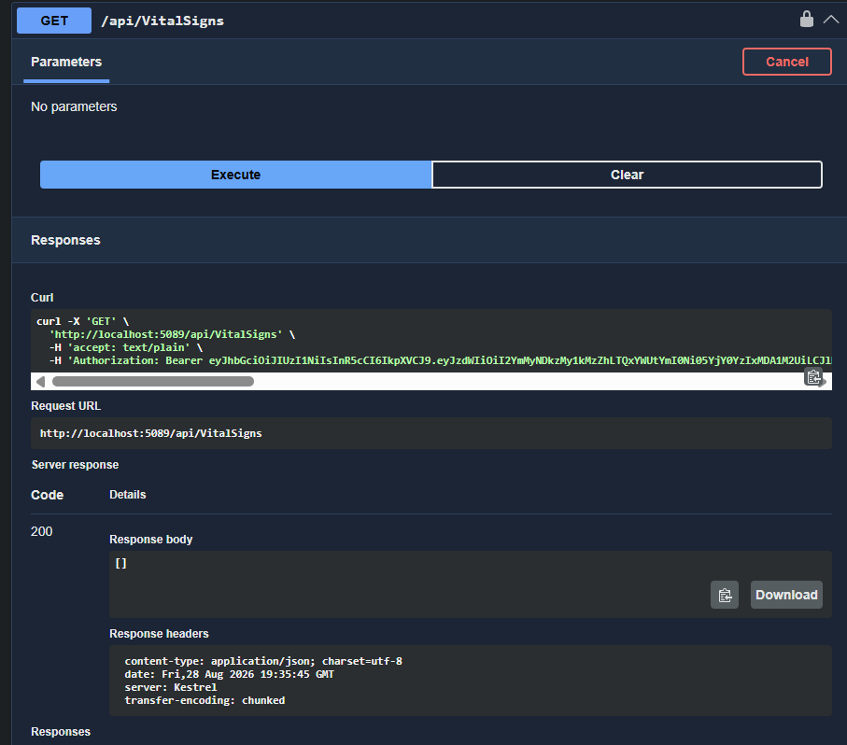

17. Get Vital Sign by ID

Endpoint
GET /api/VitalSigns/{id}

Expected Results
Existing record:
200 OK
Non-existing record:
404 Not Found

Screenshots
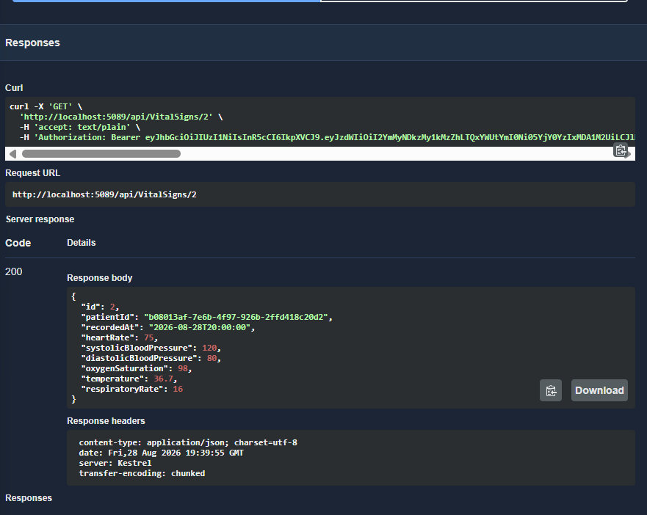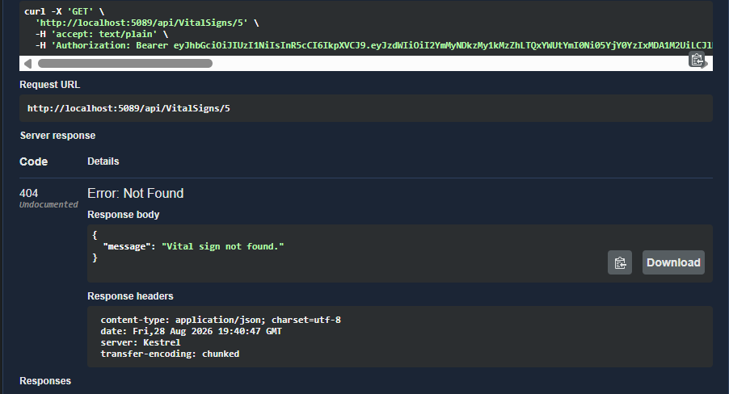

18. Get Patient Vital Signs

Endpoint
GET /api/VitalSigns/patient/{patientId}

Purpose
Retrieves all vital-sign measurements belonging to a specific patient.
The API first checks whether the patient exists.

Expected Results
Existing patient:
200 OK
Non-existing patient:
404 Not Found

Screenshot
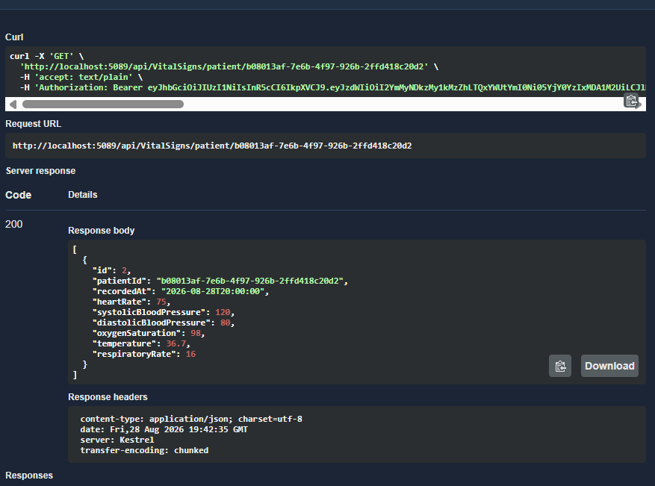

19. Create Vital Sign

Endpoint
POST /api/VitalSigns

Purpose
Creates a new vital-sign measurement.
The request uses:
CreateVitalSignRequest
and is validated using FluentValidation.

Expected Results
Successful request:
201 Created
Invalid request:
400 Bad Request
Patient does not exist:
404 Not Found

Screenshots
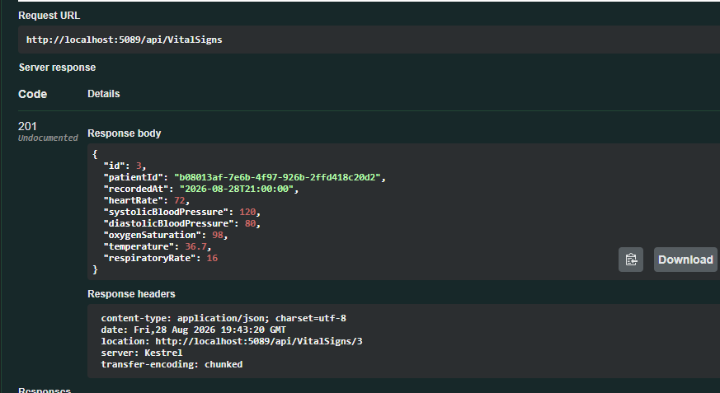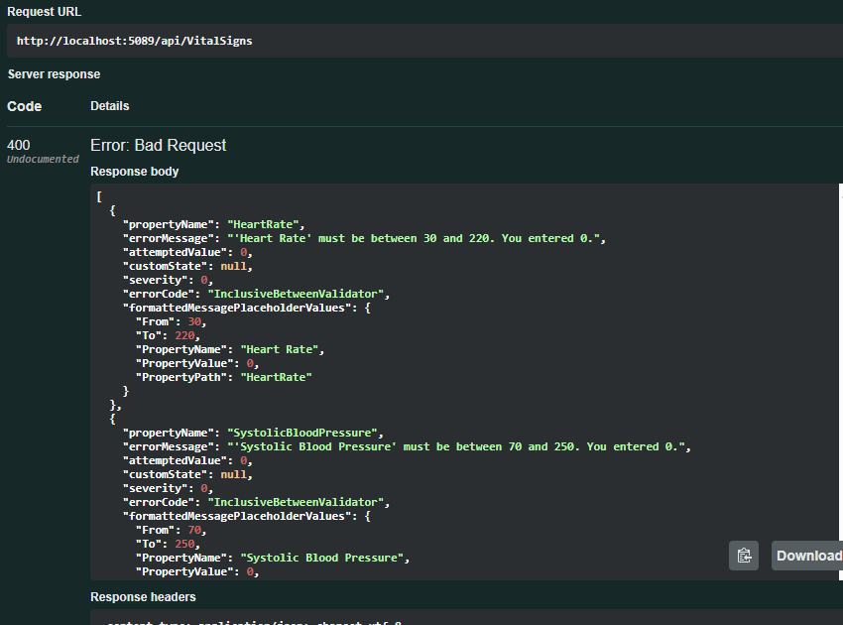

20. Update Vital Sign

Endpoint
PUT /api/VitalSigns/{id}

Expected Results
Successful update:
204 No Content
Record not found:
404 Not Found
Validation error:
400 Bad Request

Screenshots
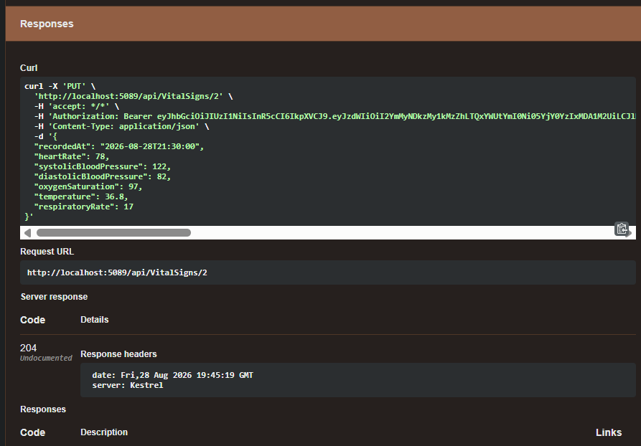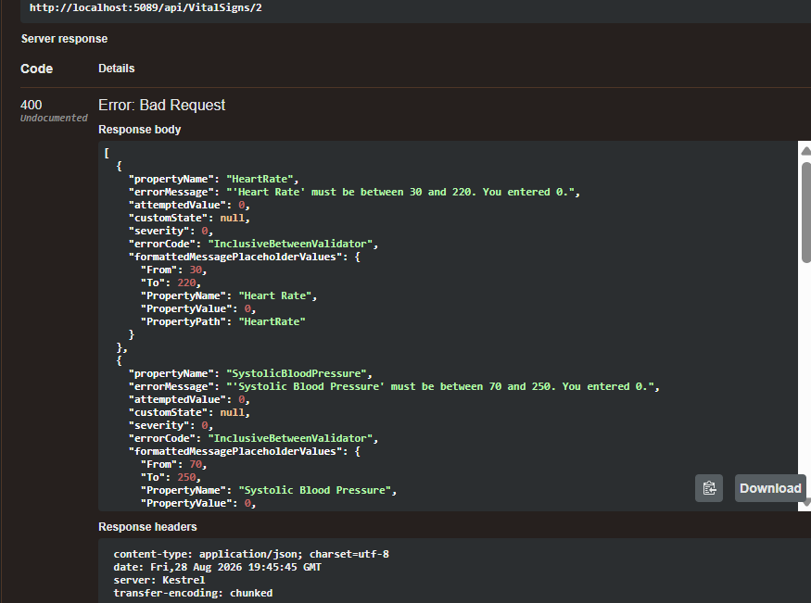

21. Delete Vital Sign

Endpoint
DELETE /api/VitalSigns/{id}
This endpoint requires the Admin role.

Expected Results
Admin:
204 No Content
Non-admin:
403 Forbidden
Record not found:
404 Not Found

Screenshots
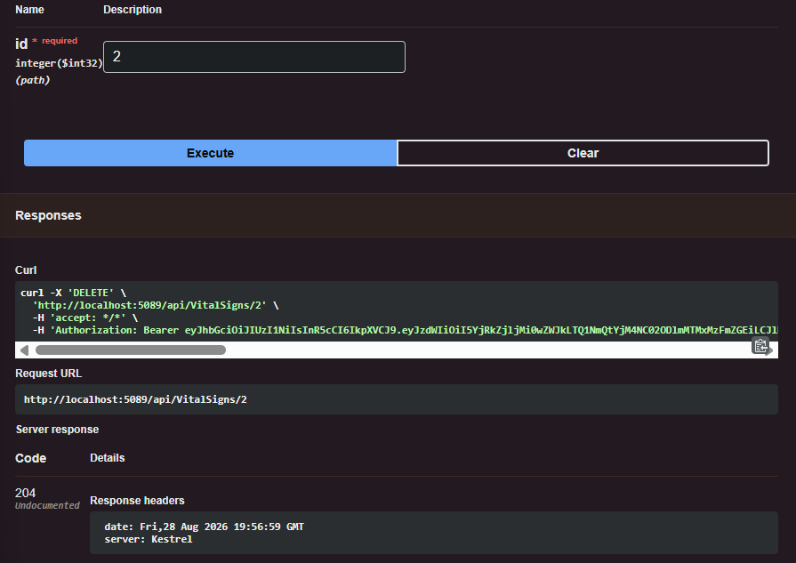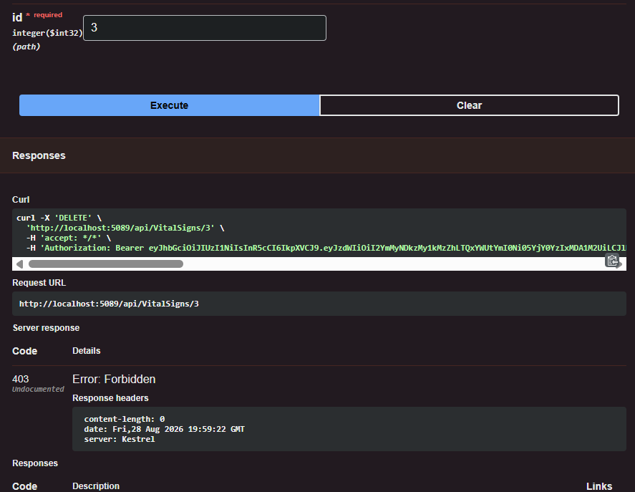

36. Validation Testing
FluentValidation was tested by sending invalid requests to create and update endpoints.
When validation fails, the API returns:
400 Bad Request
The response contains the validation errors generated by the corresponding validator.
Validation was implemented for:
- Patients
- Vital Signs
- Medications
- Appointments

Screenshot
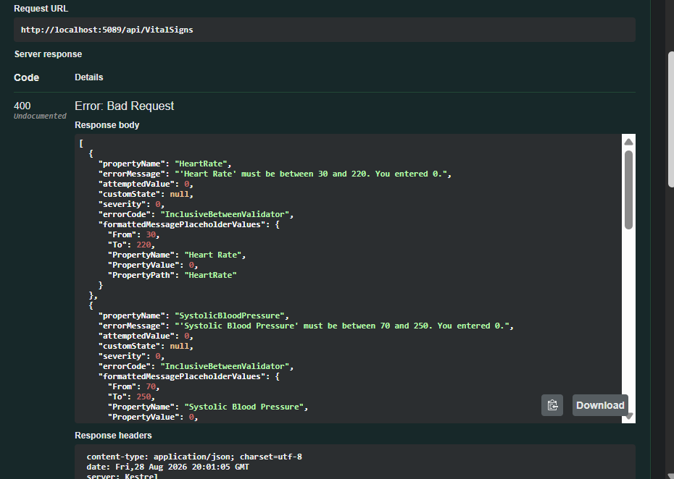

38. HTTP Status Codes Tested
Status Code | Meaning | Example
200 | OK | Successful GET/Login
201 | Created | Successful POST
204 | No Content | Successful PUT/DELETE
400 | Bad Request | Validation failure
401 | Unauthorized | Missing/invalid authentication
403 | Forbidden | Insufficient role
404 | Not Found | Resource does not exist
409 | Conflict | Duplicate registration

39. Database Seed Data Verification
The seeded data was used to verify that the API can retrieve existing records immediately after database initialization.
The seed data covers:
- Patients
- Vital Signs
- Medications
- Appointments
- Medical Conditions
- Allergies
The seeded records can be used when testing relationships and patient-specific endpoints.

Screenshot

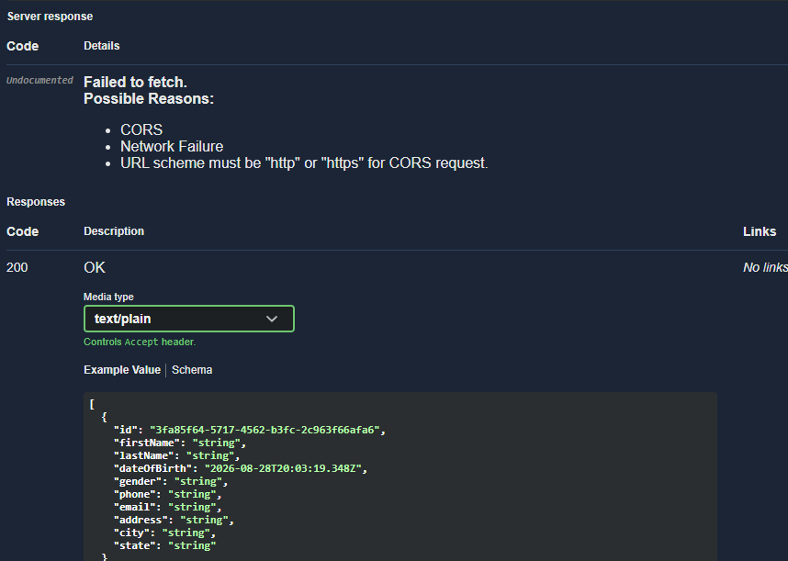Screenshot

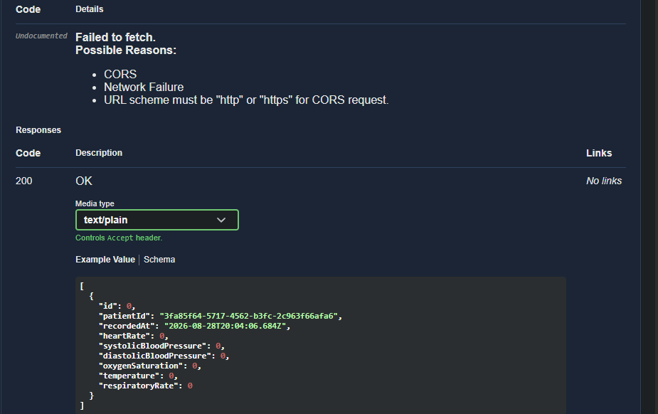Screenshot

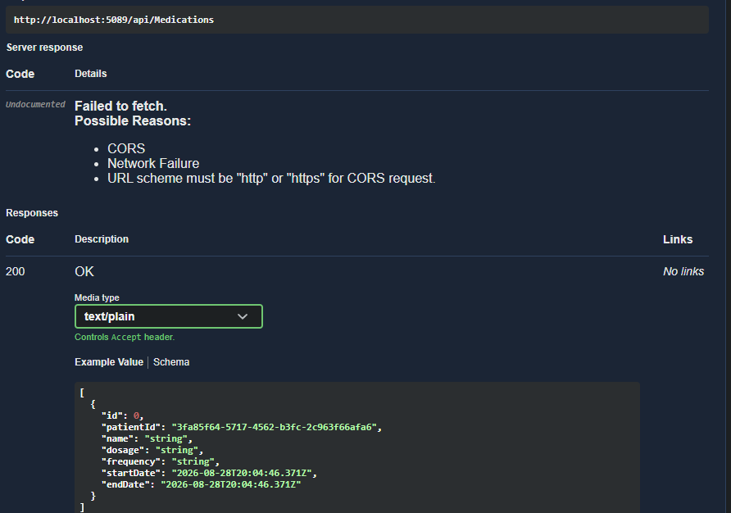Screenshot
